

|  |  |  |  |  |  |  |  |  |
| --- | --- | --- | --- | --- | --- | --- | --- | --- |
|  | | | | | | | | |
|  | | DOCUMENTATION | | | | |  | |
|  |  | | | | | | |  |
|  | | | |  |  | | | |
|  | | | | Tarun Agarwal University ID: 77356692 |  | | | |
|  | | | | January 20, 2025—Advanced Web Engineering—Job Portal (TBC Career Quest) |  | | | |
|  | | |  | | |  | | |

|  |  |  |  |  |  |  |  |  |
| --- | --- | --- | --- | --- | --- | --- | --- | --- |
|  |  | | |  |  | | |  |
|  | INTRODUCTION | | | | | | |  |
|  |  | | |  |  | | |  |
|  |  | |  | | |  | |  |
|  |  |  | TBC Career Quest is a web-based job portal developed as an assessment project using the Laravel Framework. The primary objective of this project is to provide a seamless and continuous platform for job listings and applications, addressing the limitations of a traditional two-day annual job fair event. With TBC Career Quest, students, alumni, and employers can interact throughout the year, offering a dynamic and accessible solution to career opportunities.  The portal allows employers to post job openings, while students and alumni can explore, apply, and track these opportunities conveniently. It fosters better engagement, saves resources, and ensures that career opportunities are always within reach for the TBC community. This project reflects an innovative approach to bridging the gap between job seekers and providers, enhancing the overall employment experience.  YouTube Video Link:  Github Respository Link : https://github.com/tbc-bsc-l6/component-2-Agarwal7Tarun | | |  |  |  |

|  |  |  |  |  |  |  |
| --- | --- | --- | --- | --- | --- | --- |
|  | | TECH STACK | | |  | |
|  | |  |  |  |  | |
|  | 1. Visual Studio Code 2. Xampp (Apache, MySQL) 3. PHP 4. Composer 5. Stater Kit: Laravel Breeze 6. CSS Framework: Bootstrap 7. JavaScript 8. Database Used: MySQL | | | | |  |

|  |  |  |  |  |  |  |
| --- | --- | --- | --- | --- | --- | --- |
|  | | PROJECT SETUP GUIDE | | |  | |
|  | |  |  |  |  | |
|  | This guide provides step-by-step instructions to set up and execute the TBC Career Quest project. Please follow these steps carefully to ensure the application runs smoothly.  **1. Setup the Environment**   * Create a .env file in the root directory of the project. The .env file is required for configuring the project and has been excluded from the repository for security purposes. * Add your SMTP credentials in the .env file to enable email functionality (e.g., for notifications or password resets).   **2. Database Configuration**   * Ensure you have a MySQL server running. * Run the following command to migrate the database and create all necessary tables:   php artisan migrate   * A SQL file is provided in the repository. Import this file into your MySQL server to pre-populate the database structure and data. * Update the .env file with your database credentials (e.g., DB_DATABASE, DB_USERNAME, DB_PASSWORD).   **3. Run the Application**   * Start your MySQL server. * Launch the project server using the following command:   php artisan serve   * The project will now be accessible in your browser at <http://localhost:8000>   **4. Accessing the Application**  **Login Credentials**   * **Admin User**   + Email: atarun21@tbc.edu.np   + Password: Test123 * **Standard User**   + Email: Test@test.com   + Password: Test123   **5. Roles and Access**  **Admin**   * Admin users will see the same interface as standard users upon login. * Admins have an additional **Admin Panel** option in the header menu. This panel provides **master control**, including:   + Deleting jobs   + Editing job details   + Featuring jobs   + Managing user-created jobs   + Overseeing all other functionalities   **Standard User**   * Standard users can:   + Apply for jobs.   + Create jobs for others to apply to. * **Note**: Users cannot apply for the jobs they create themselves.   **6. Additional Notes**   * Ensure all required dependencies are installed using:   composer install  npm install  npm run dev   * Test the application after setup to confirm all features are functioning as intended. | | | | |  |

|  |  |  |  |  |
| --- | --- | --- | --- | --- |
|  | | EXTENDED FEATURES LIST | | |
|  | |  |  |  |
|  | 1. Email Notification 2. Reset Password 3. Pagination 4. News API 5. Save / Apply / Post Jobs | | | | |

|  |  |
| --- | --- |
|  | PICTURES |

1. Source Code
   1. Controllers

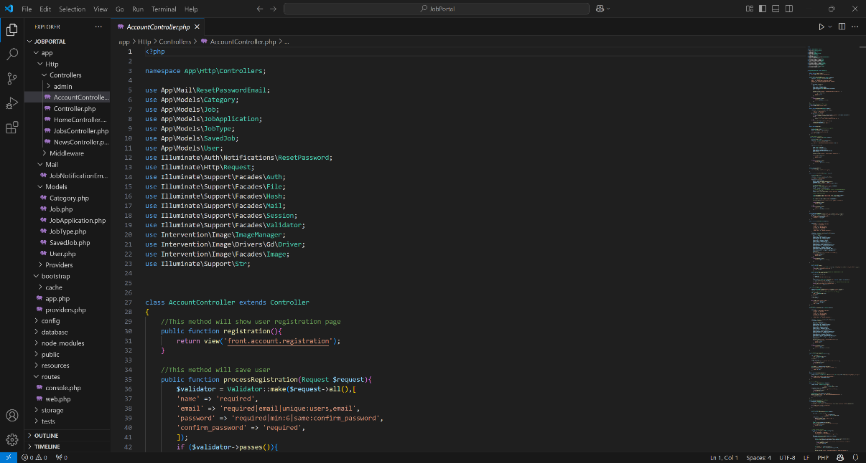

* 1. Models

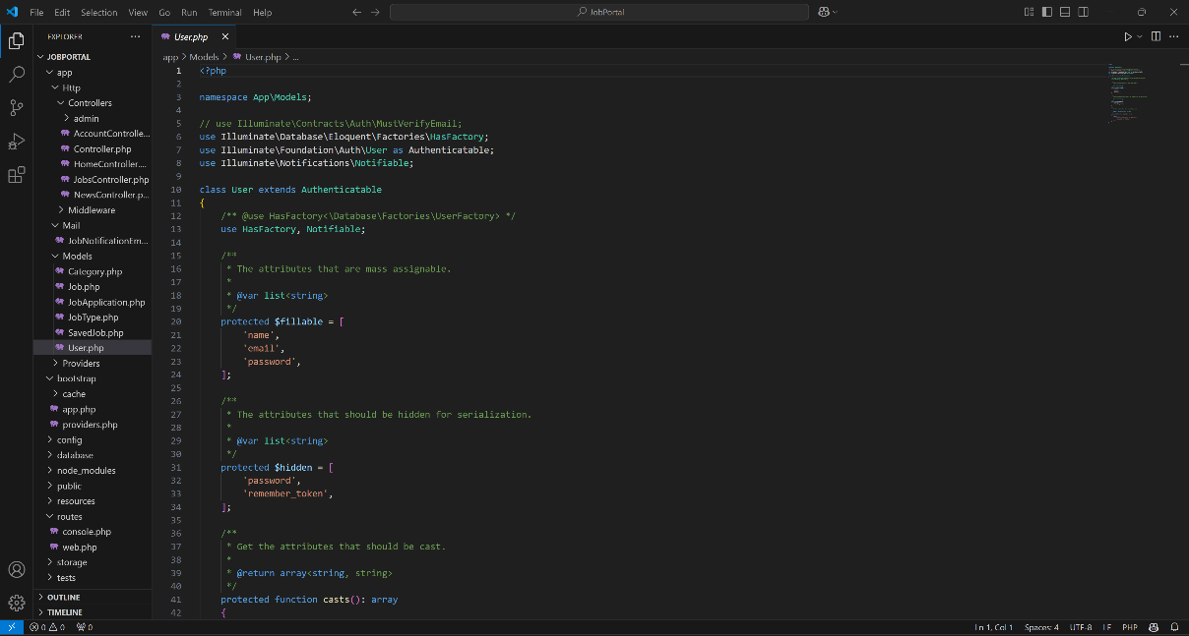

* 1. Factory

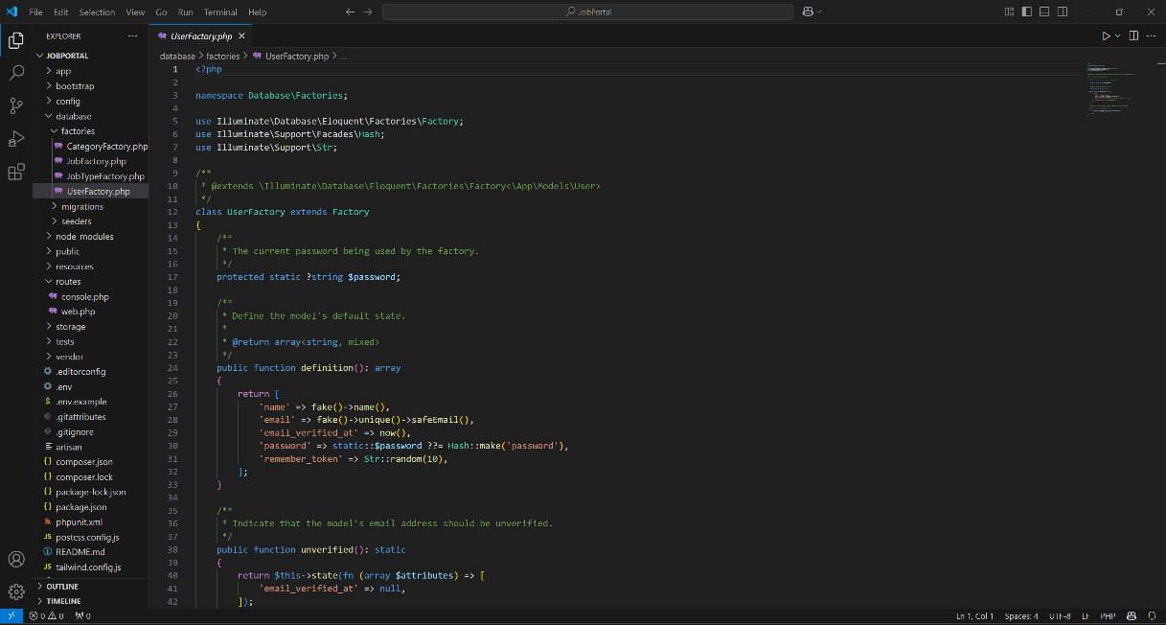

* 1. Migration

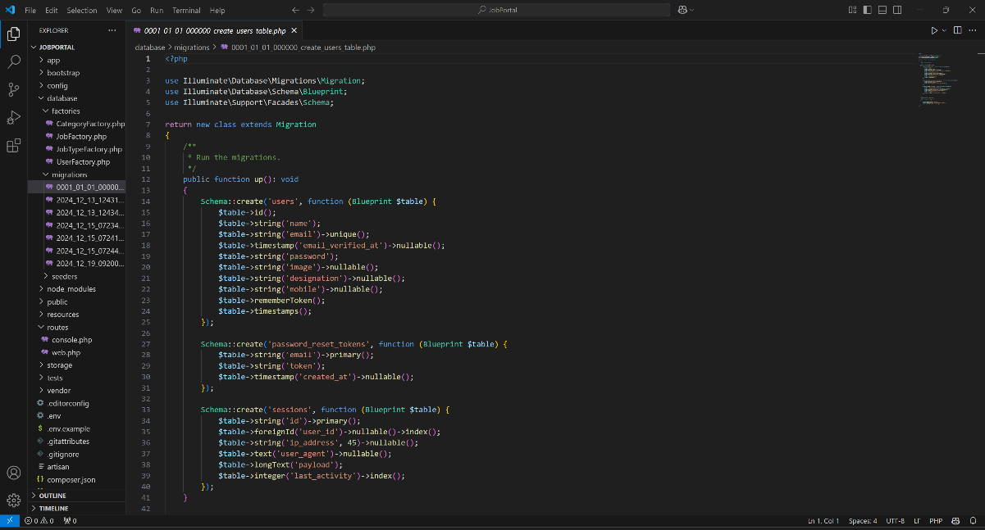

* 1. Seeders

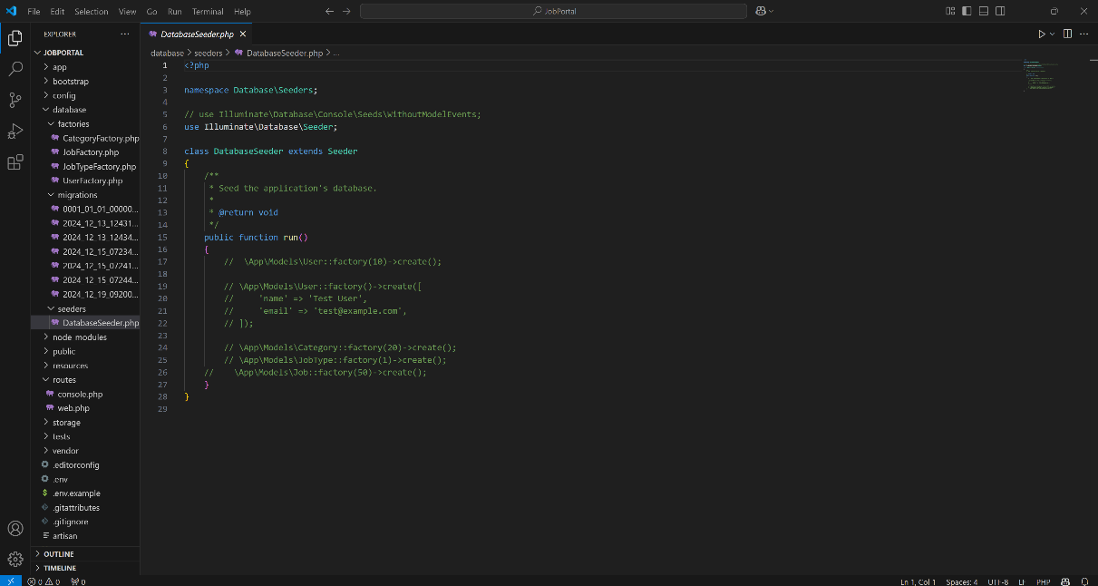

* 1. Views

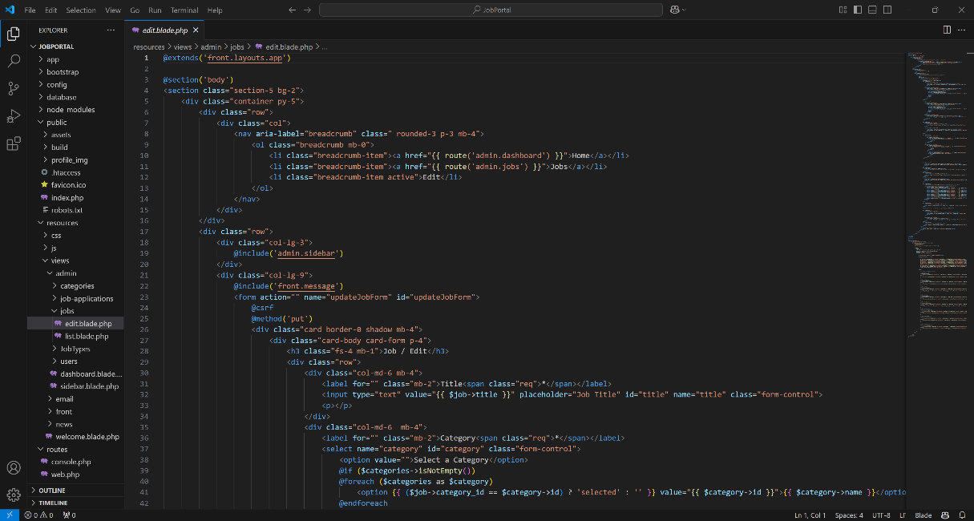

* 1. Routes

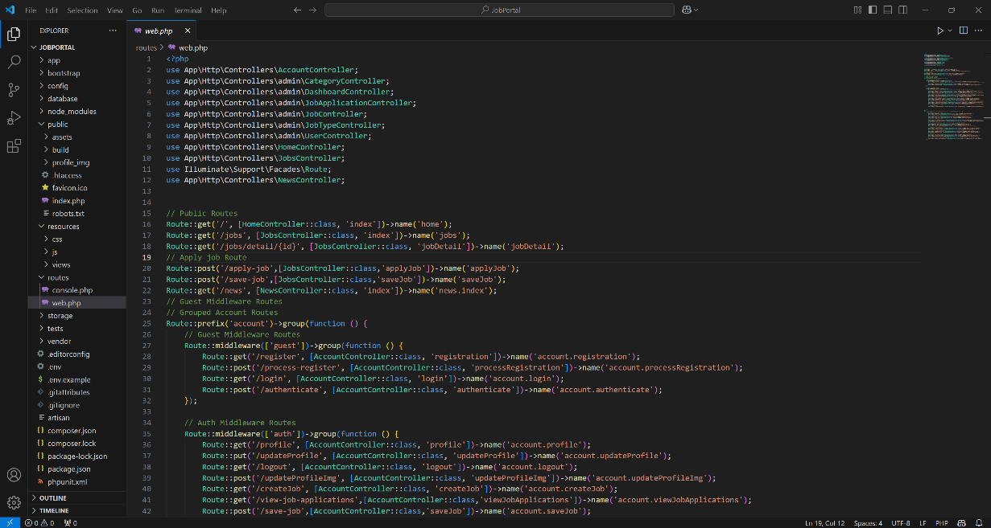

* 1. .env

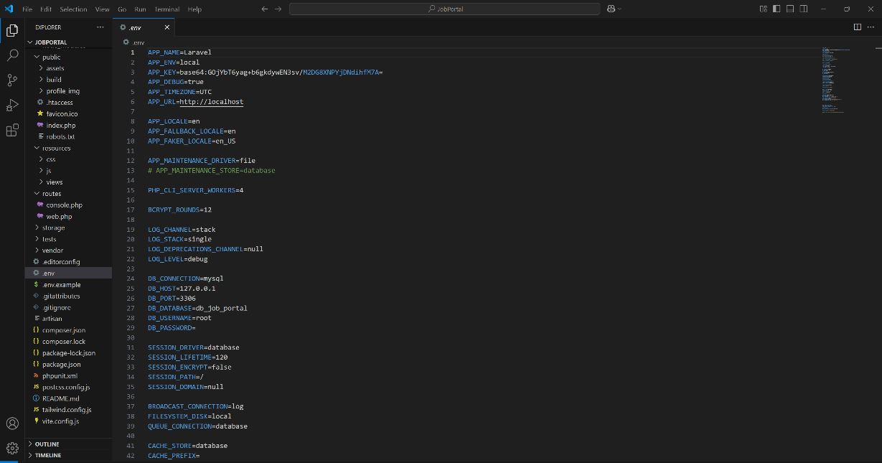

1. Website Before Login
   1. Home Page Before Login

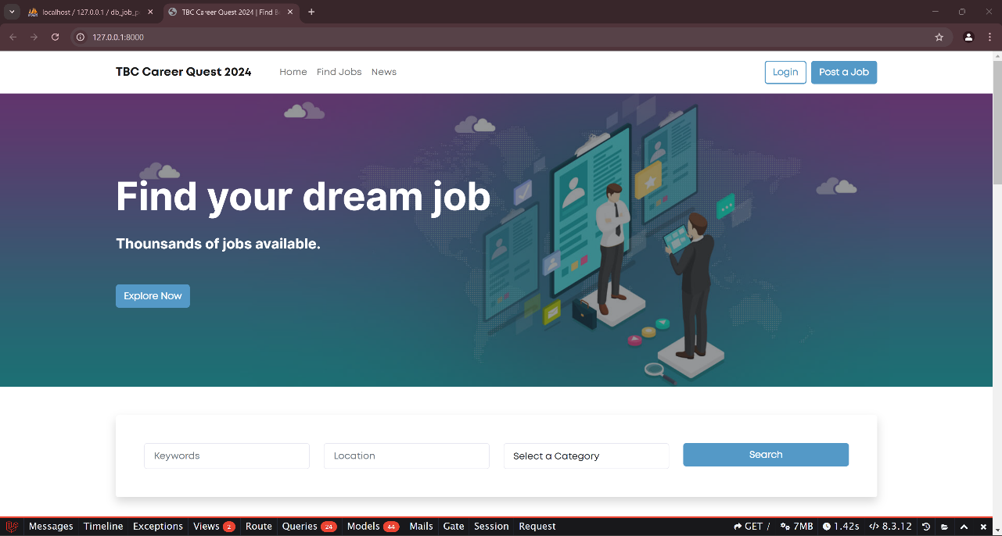

* 1. Job Details Page Before Login

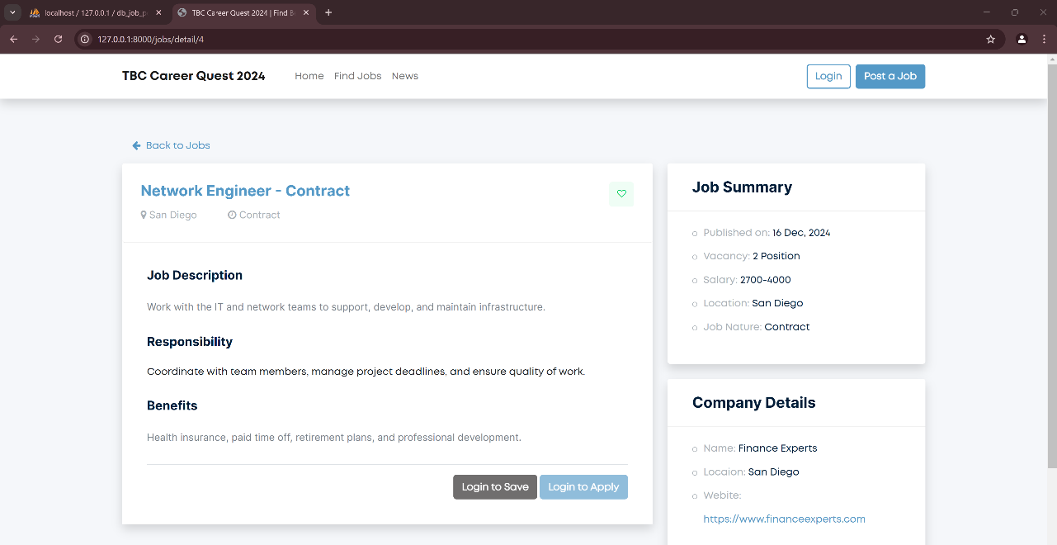

* 1. Invalid Login Credentials

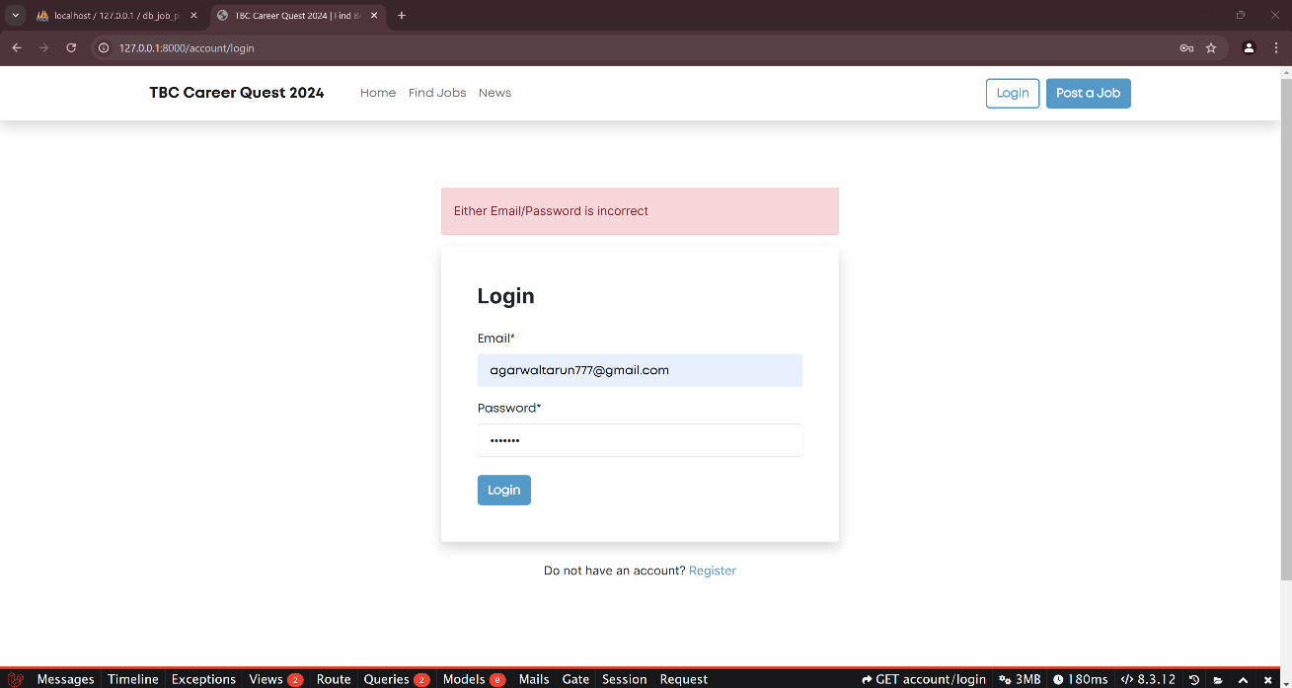

1. Website After User Login
   1. Profile Page

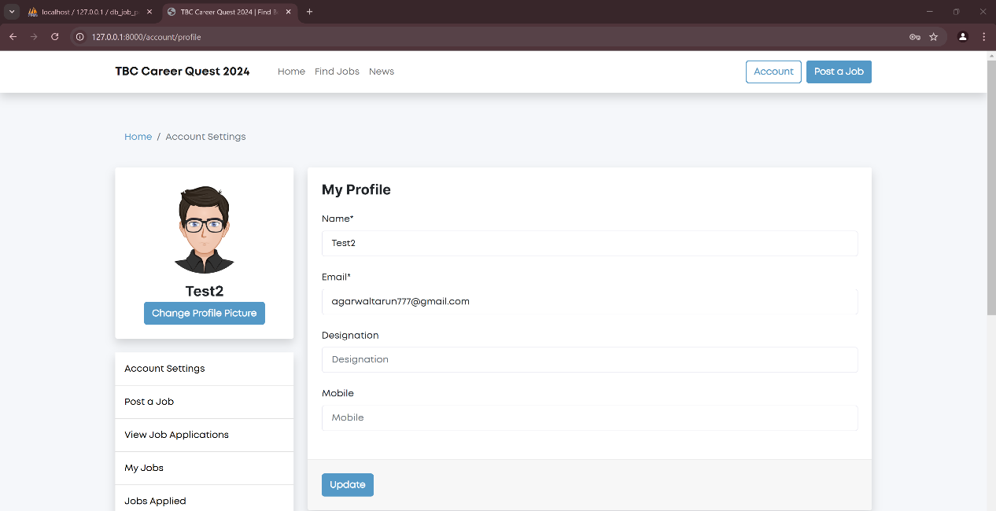

* 1. Home Page After Login

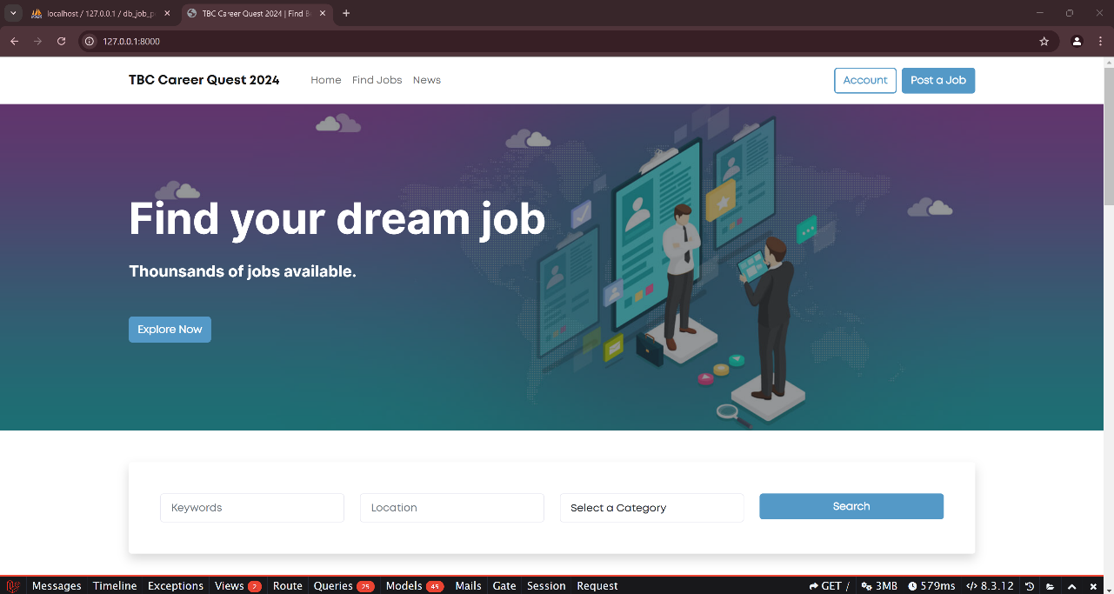

* 1. Job Details Page After Login

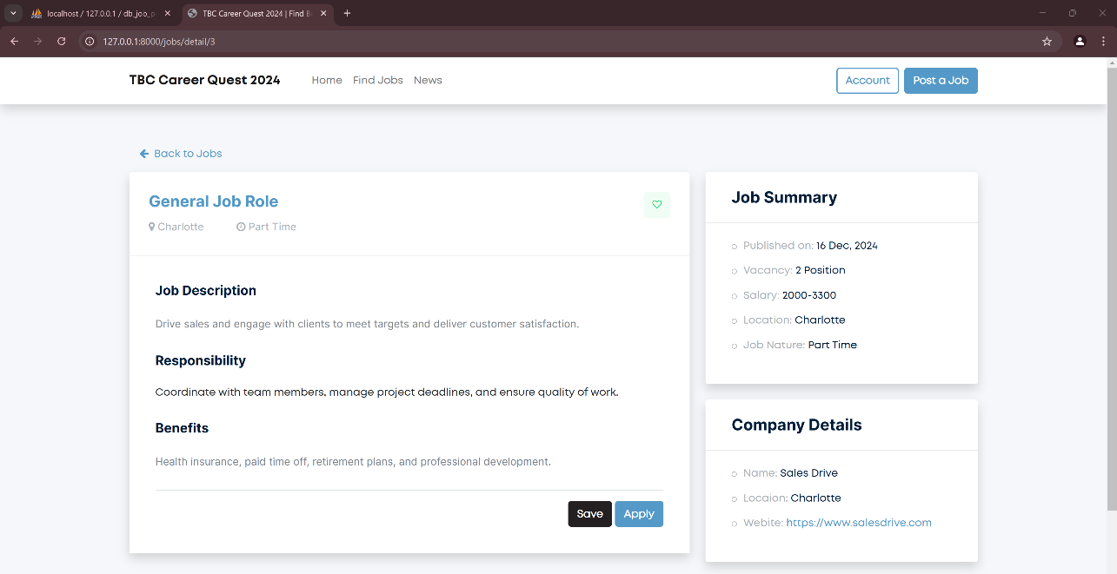

* 1. Job Saved Message

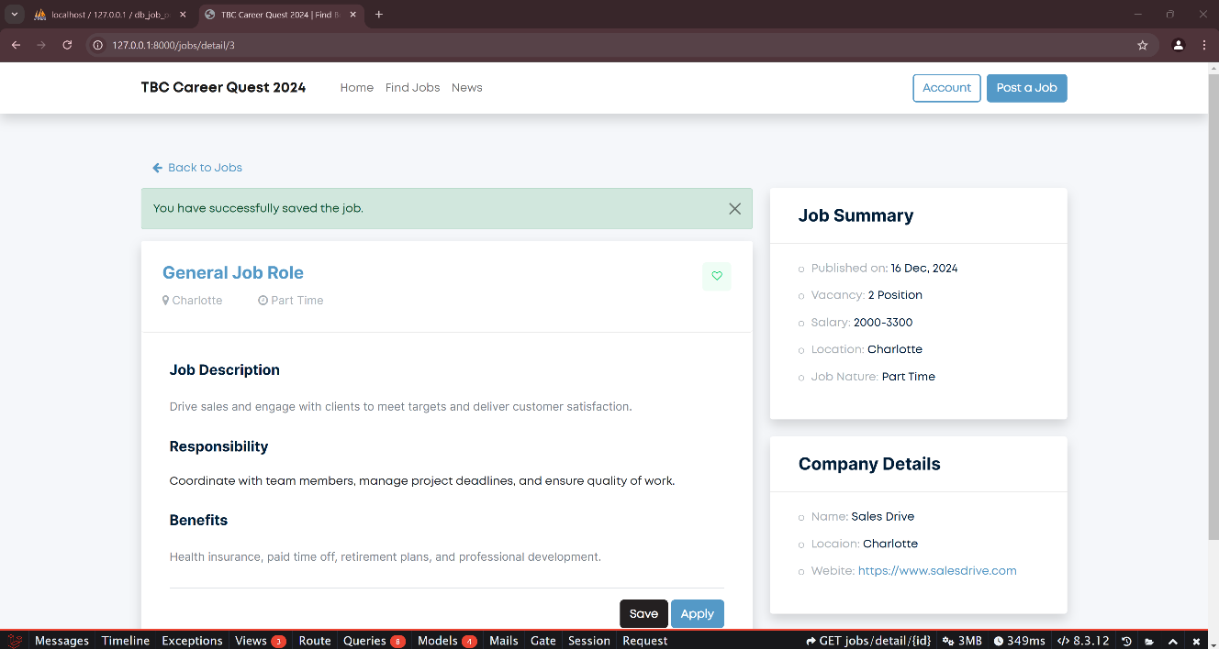

* 1. Job Apply Confirmation Message

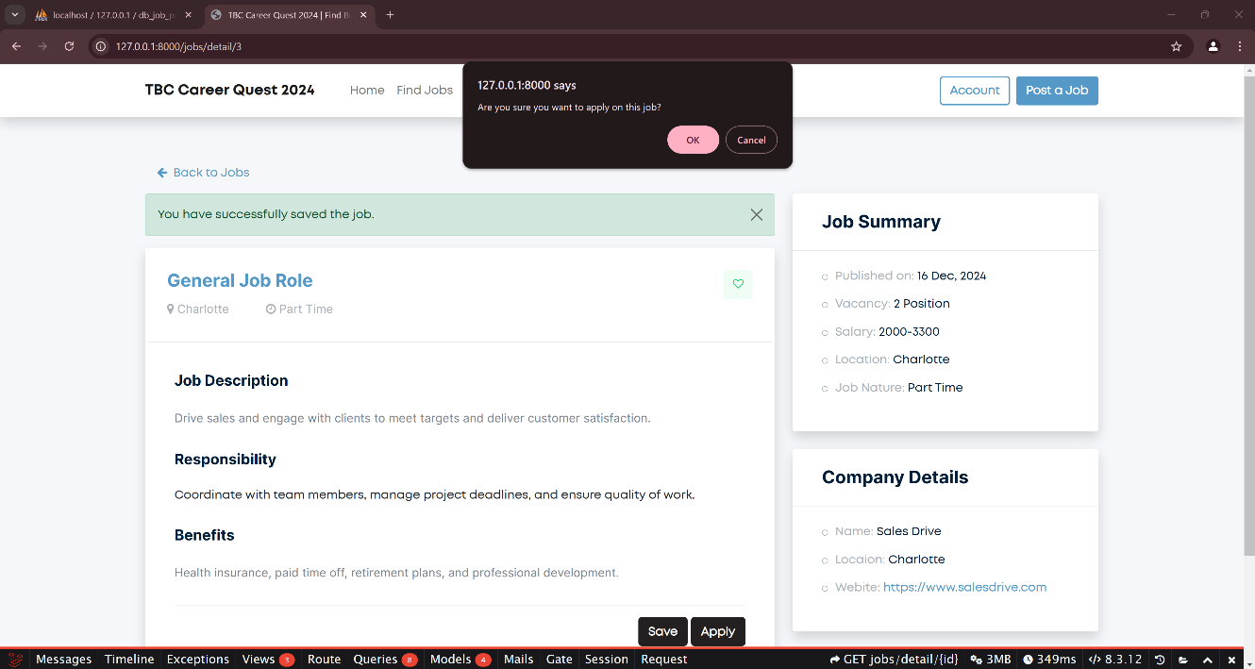

* 1. Error Handling Message

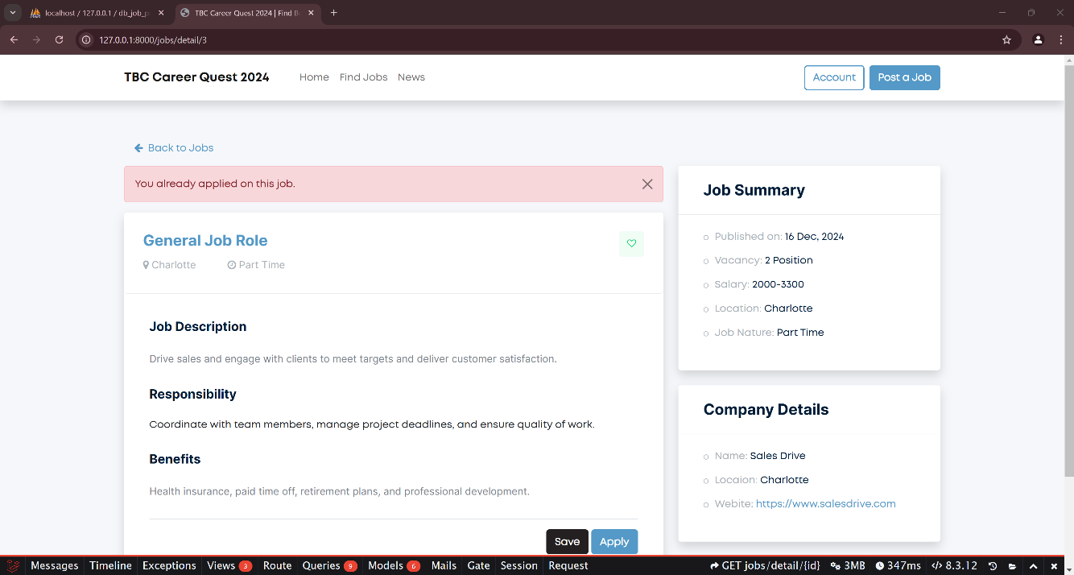

* 1. Find Jobs with Searching and Sorting

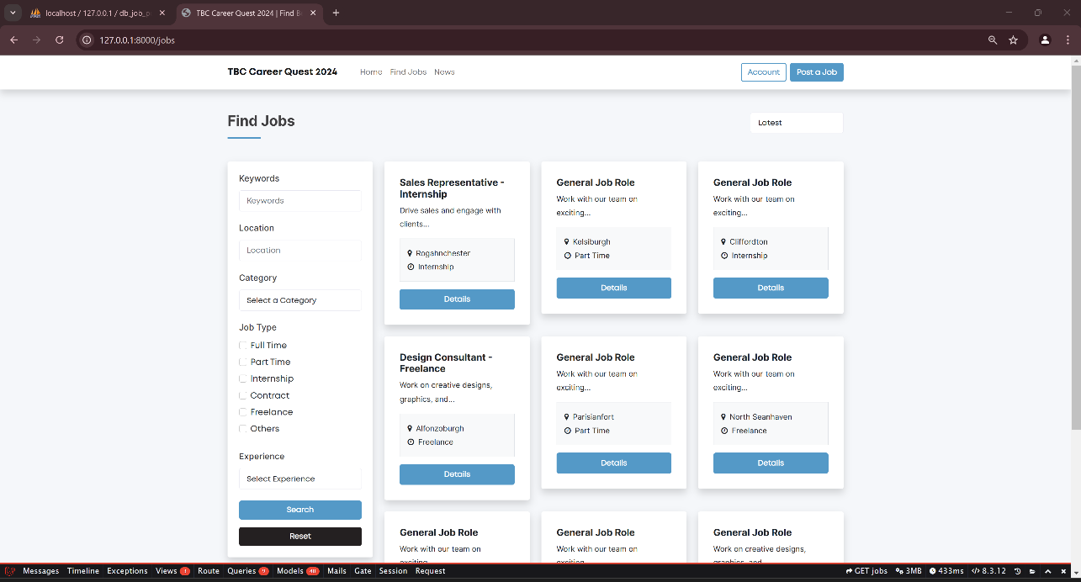

* 1. News page fetched Via API

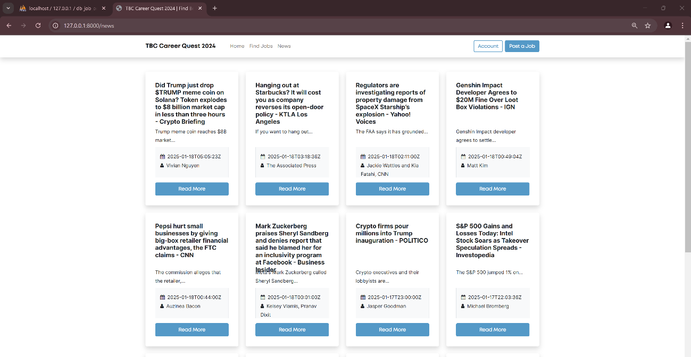

* 1. Post a Job Page

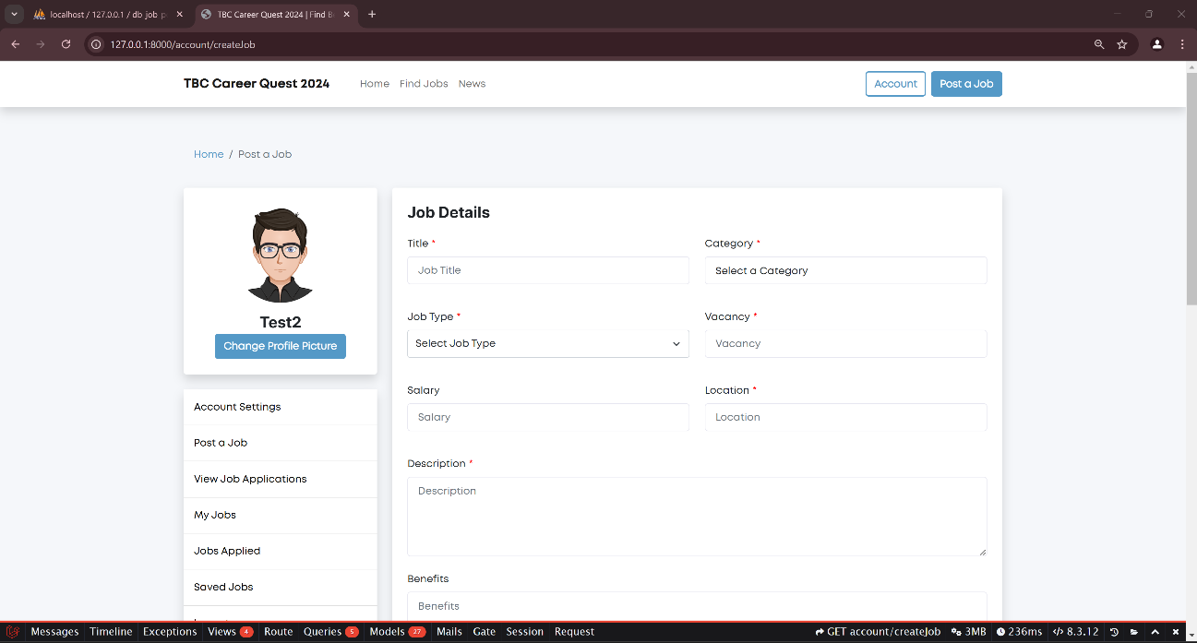

* 1. Self-Posted Job Listing

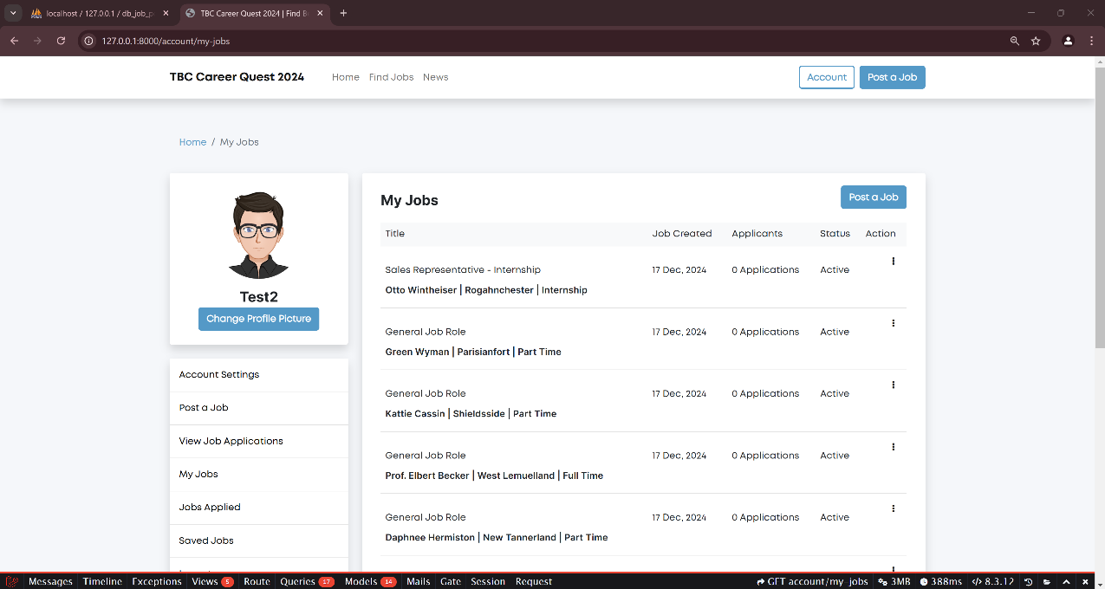

* 1. Self-Applied Jobs Applications

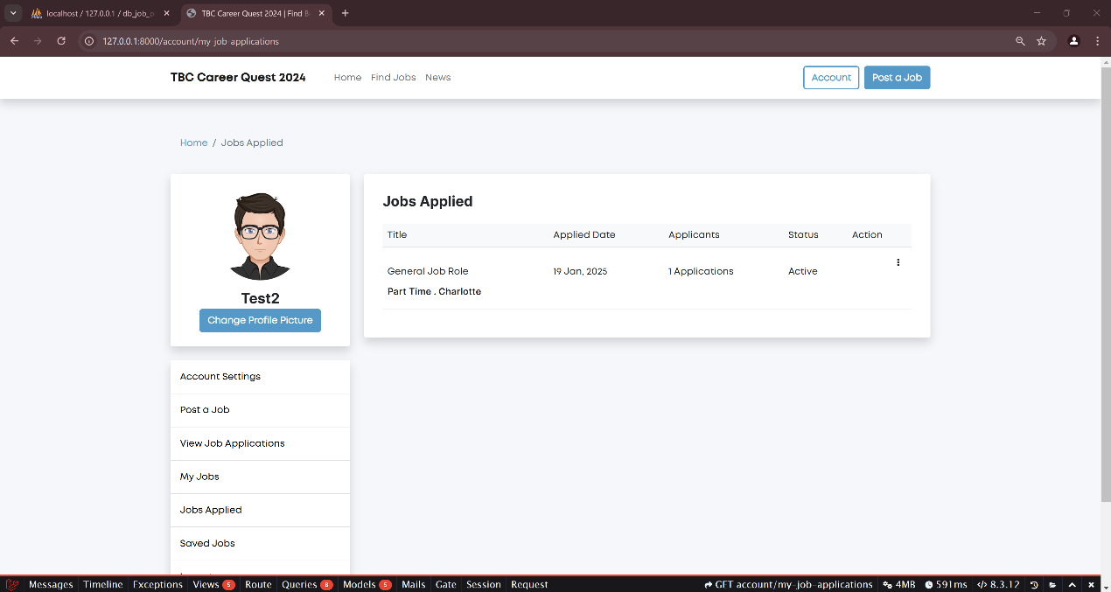

* 1. Job Applicants

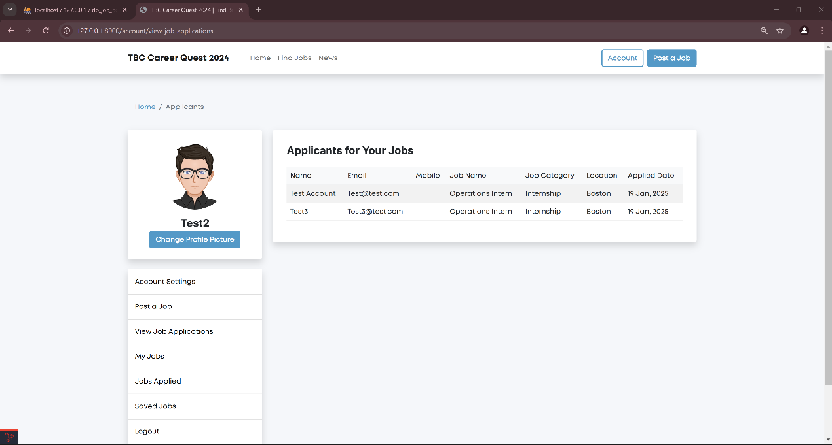

* 1. Email Notification

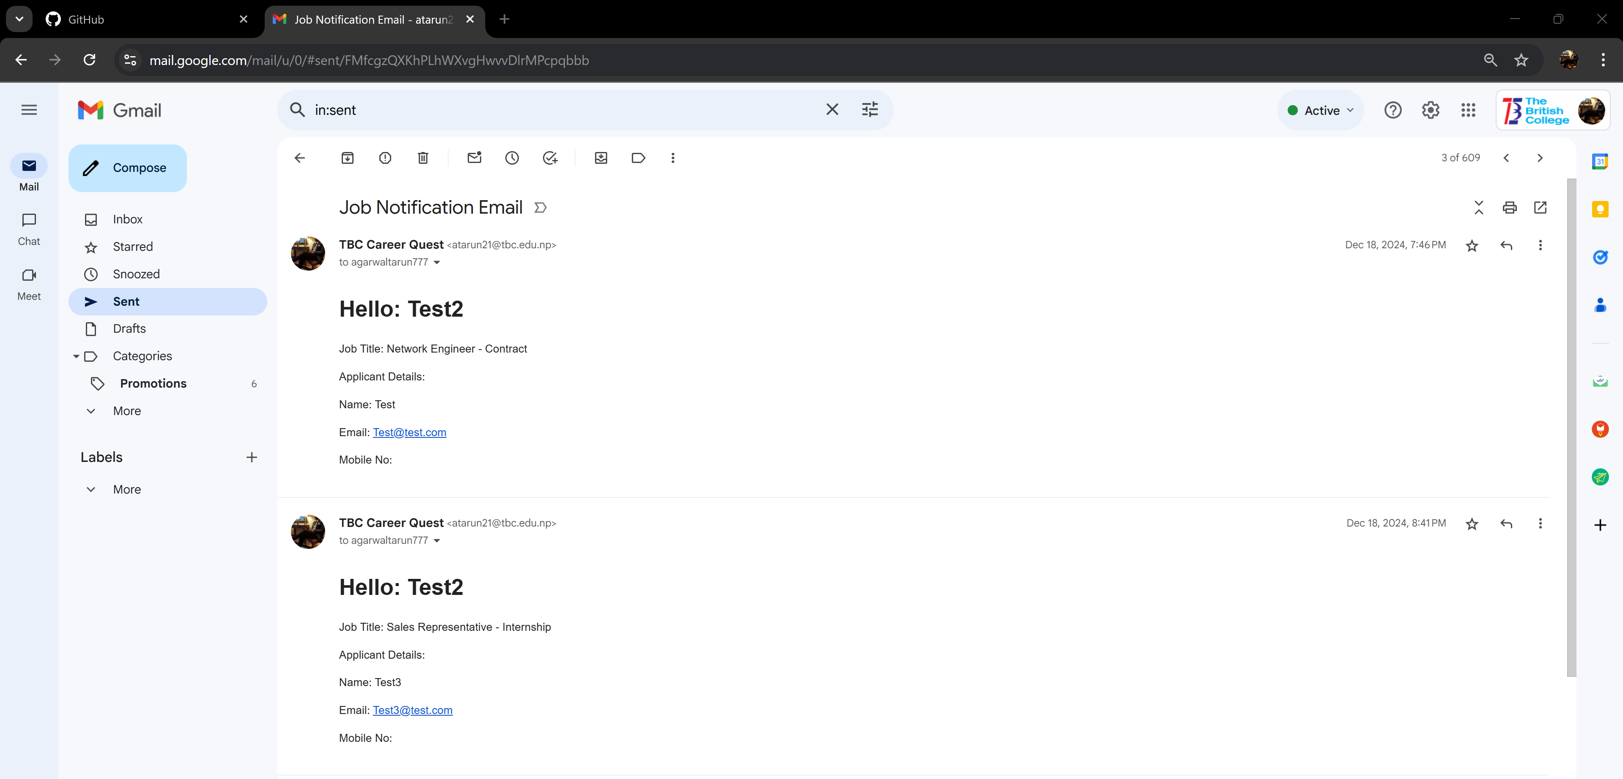

1. Website After Admin Login
   1. Admin Profile Page

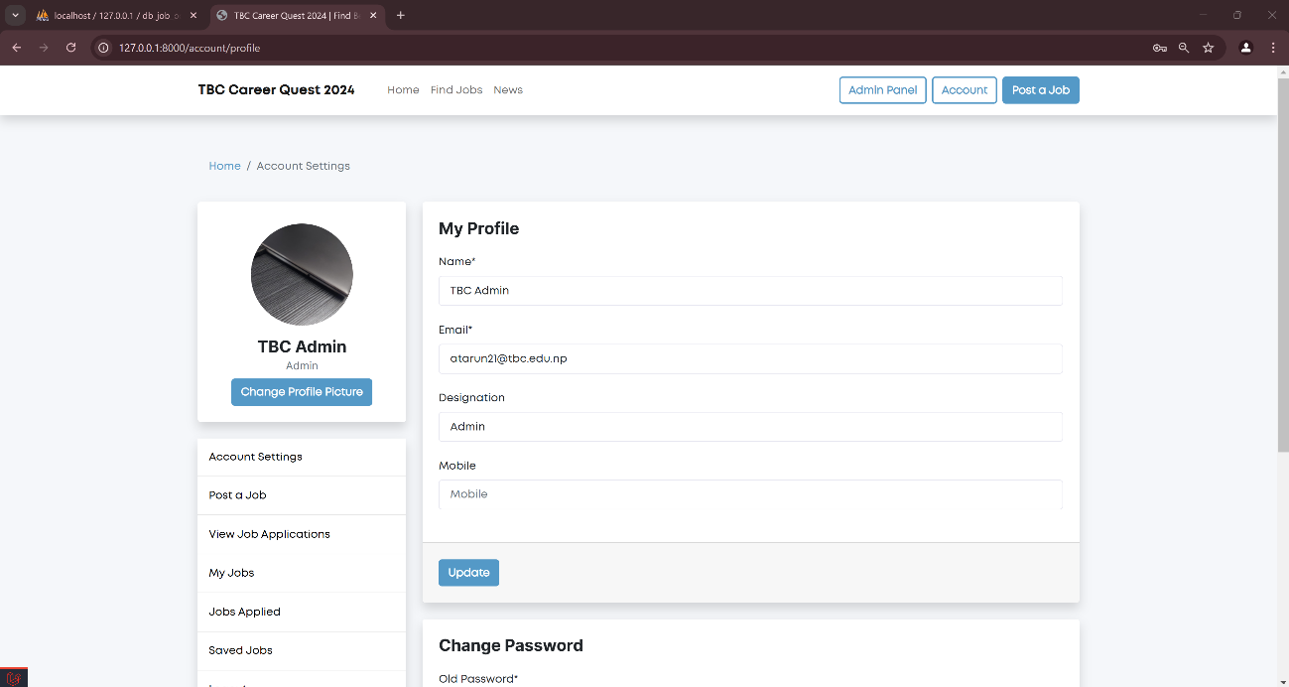

* 1. Admin Panel

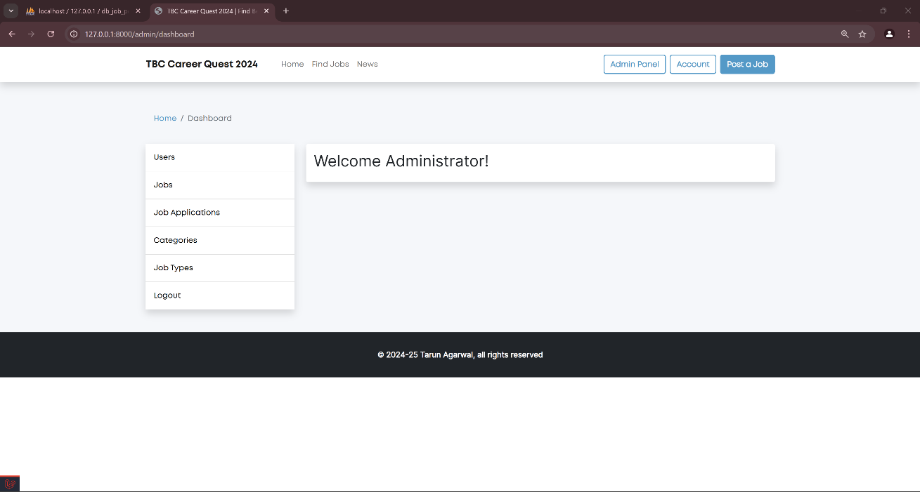

* 1. Admin Job List

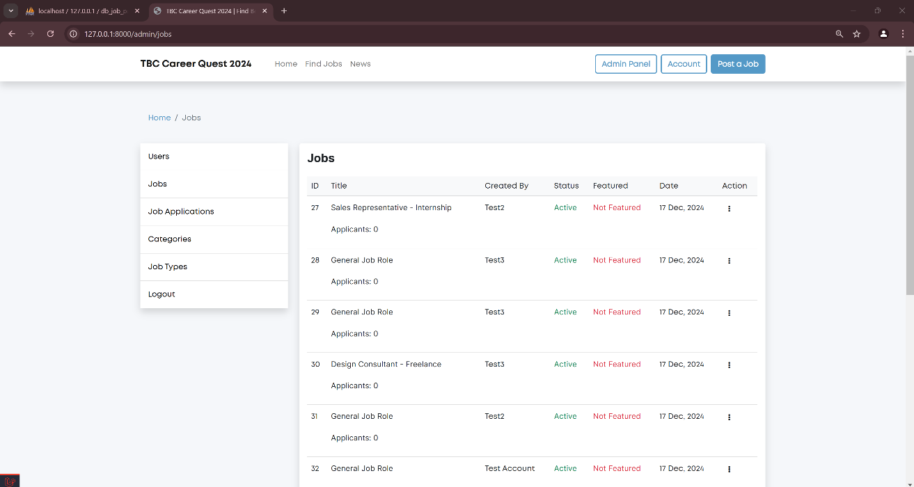

* 1. Admin Job Application Page

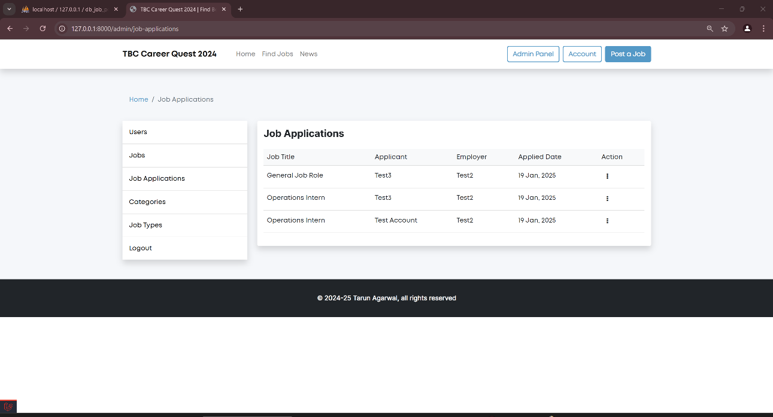

* 1. Admin Job Categories Page

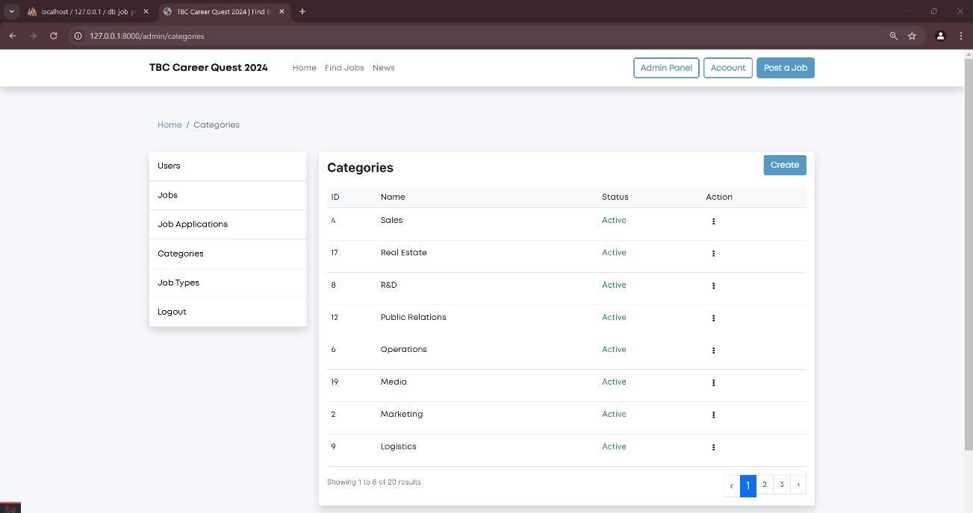

* 1. Admin Job Types

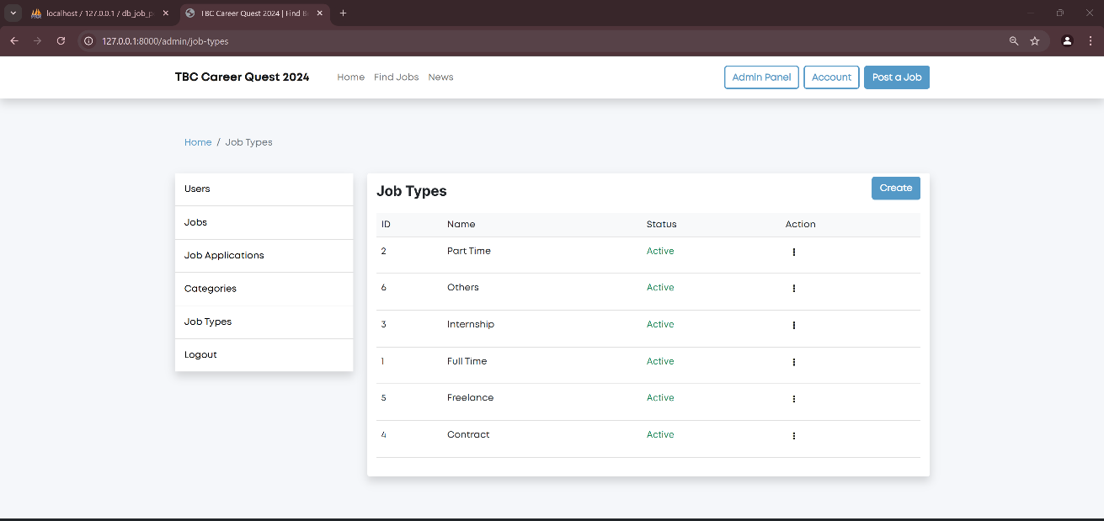

1. MySQL
   1. Users Table

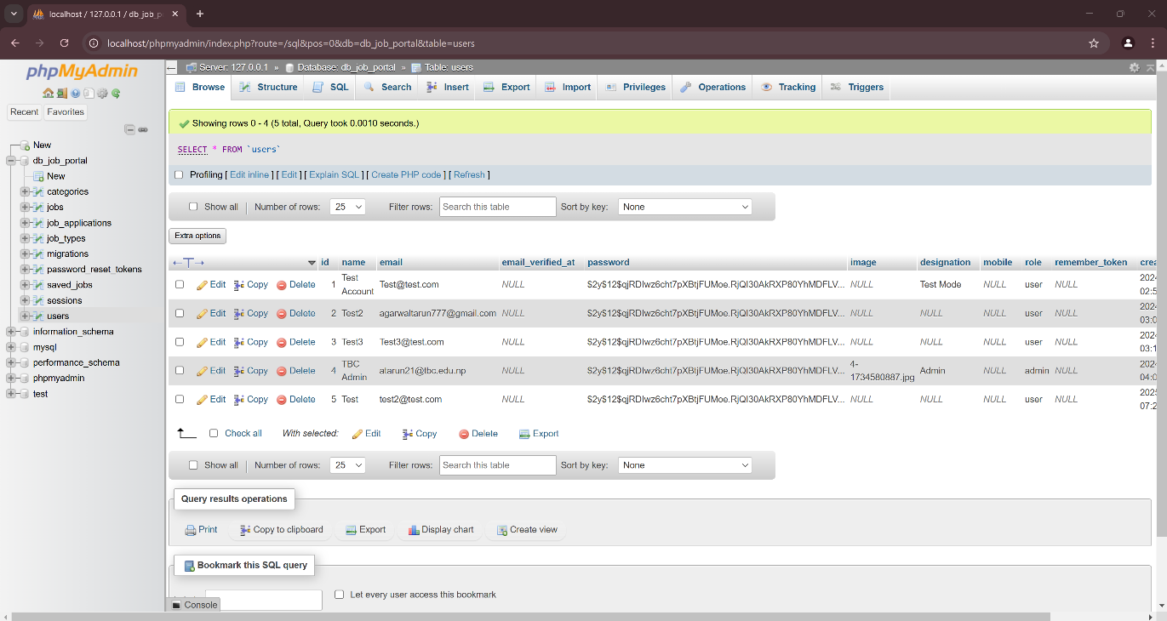

1. GitHub
   1. Component 2
      1. JobPortal – Source Code
      2. db_job_portal – SQL File

